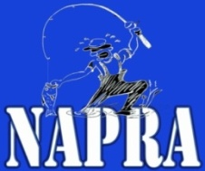

NAPRA MEMBERSHIP WAIVER
Please fill out the information and sign the waiver and return to the address below:

MEMBERSHIP FORM:
NAME
ADDRESS
CITY/STATE/ZIP
CONTACT PHONE
EMAIL
EMERGENCY CONTACT:
FACEBOOK NAME | (IF APPLICABLE)

WAIVER AGREEANCE STATEMENT:

I, _____________________ agree to become a member of NAPRA for the 2018 season. By signing this I have looked at the rules posted at the website (napraprowading.com) under “2018 Rules” and agree to them from this point forth. I additionally agree to the following statement:

I am fishing public waters on my own free will and am personally responsible for my health, equipment, and vehicle. NAPRA LLC, its board, members, and sponsors are not responsible for any issues that may come up. I also agree I will release all fish, be accurate in my recordings of fish, and not show any form of unsportsmanlike conduct in any way. I understand that I must have a valid fishing license for the state(s) I am fishing in.
__________________________________ Applicant Signature ____________Date
_______ Yes I agree to the rules and regulations of membership of NAPRA (initial please)
___________________________________ Director Signature ____________ Date

